



Crop Prediction
LAB MANUAL

Disclaimer: The content is curated from online/offline resources and used for educational purpose only
Crop Prediction using the Decision Tree Classifier

Objective:
To build a machine learning model using the Decision Tree Classifier to predict the most suitable crop for cultivation based on key agricultural features such as soil nutrients, weather conditions, and pH level. The aim is to assist farmers and agricultural planners in making data-driven crop selection decisions.

Problem Statement:
Agricultural decision-making is highly dependent on environmental conditions and soil characteristics. Choosing the right crop to cultivate under specific conditions can significantly enhance yield and sustainability. This lab activity aims to develop a crop prediction model using the Decision Tree Classifier, trained on a dataset containing key agricultural factors such as Nitrogen (N), Phosphorus (P), Potassium (K), temperature, humidity, pH level, and rainfall. The goal is to predict the optimal crop label for a given set of input values. With high model accuracy, such predictions can guide farmers and stakeholders in crop selection tailored to local soil and climatic conditions.

Equipment Required:
- Python installed with Jupyter Notebook / VS Code / Google Colab
- Libraries: pandas, numpy, matplotlib, seaborn, scikit-learn

Prerequisites:
- Basic understanding of Python programming
- Familiarity with machine learning concepts, especially Decision Tree algorithms
- Knowledge of data preprocessing and splitting datasets for training/testing
- Experience with libraries like Pandas and NumPy for data handling, Matplotlib and Seaborn for visualization, and Scikit-learn for model training and evaluation
- Awareness of agricultural parameters like soil nutrients, pH, and climate variables affecting crop growth

Note: Please refer to the Jupyter Notebook for the complete implementation of the model, including code and outputs
Dataset Description:
Dataset in .csv format with the following columns:
- N, P, K (Soil Nutrients in ppm)
- temperature (in °C)
- humidity (in %)
- ph (Soil pH value)
- rainfall (in mm)
- label (Target crop name)

Procedure:
Step 1: Import Necessary Libraries
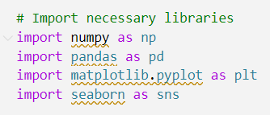

Step 2: Load and Explore the Dataset
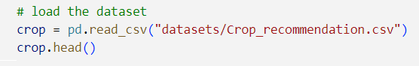
Step 3: Check the shape and basic information
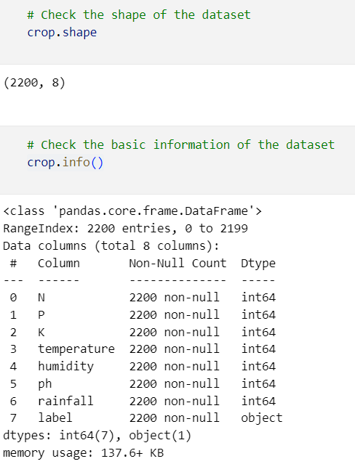

Step 4: Data Preprocessing
- Check for missing values.
- Standardize numerical features.
- Split the dataset into training and testing sets.

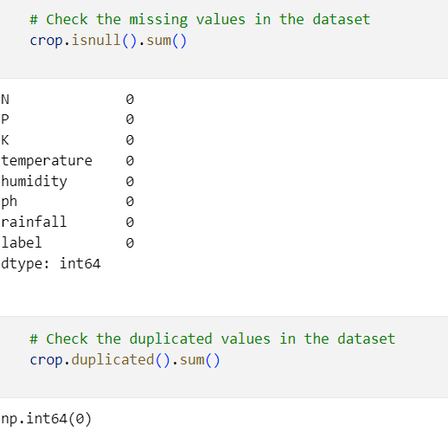

Step 4: visualize the distribution of each feature

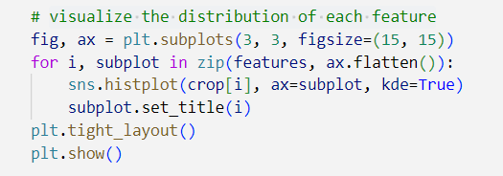
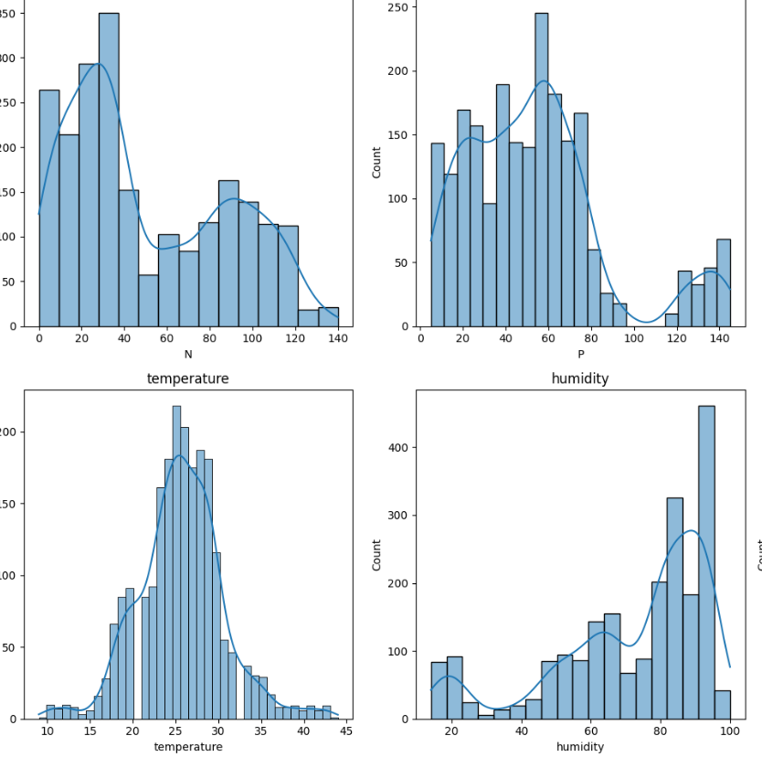

Step 5: Visualize the correlation matrix
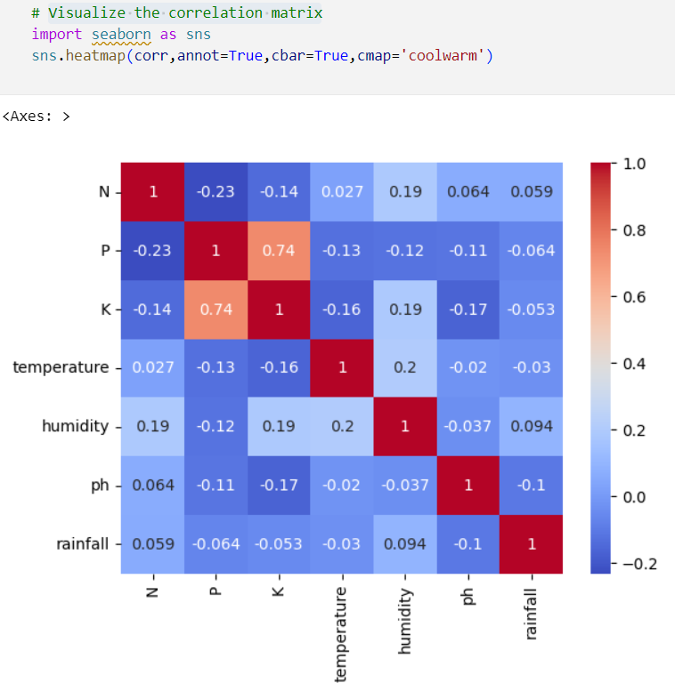

Step 6: Train and test the model
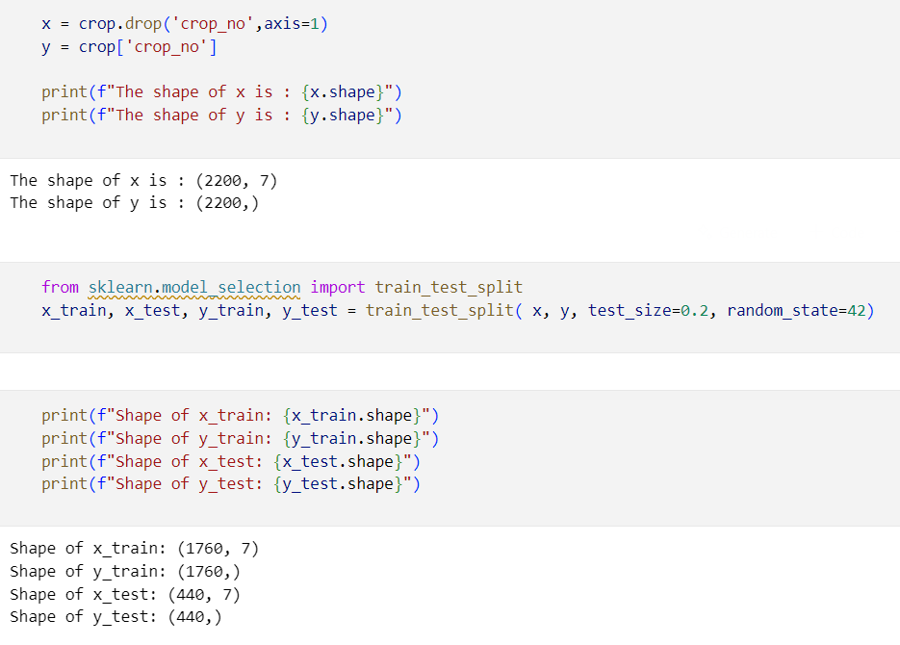
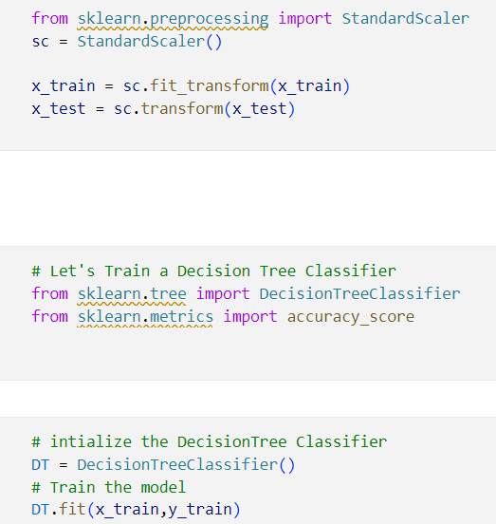

Step 7: Evaluate the model on test and train data
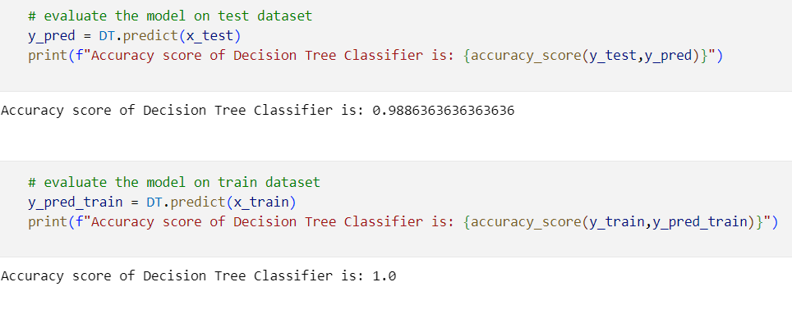

Step 8: Predict the suitable crop
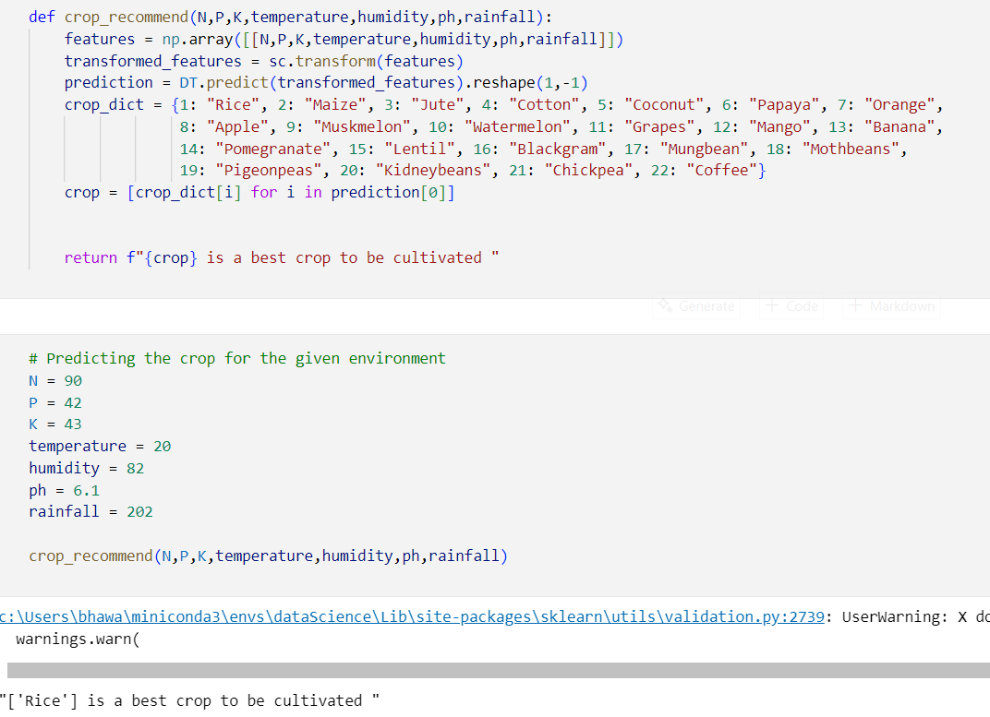

Output:

